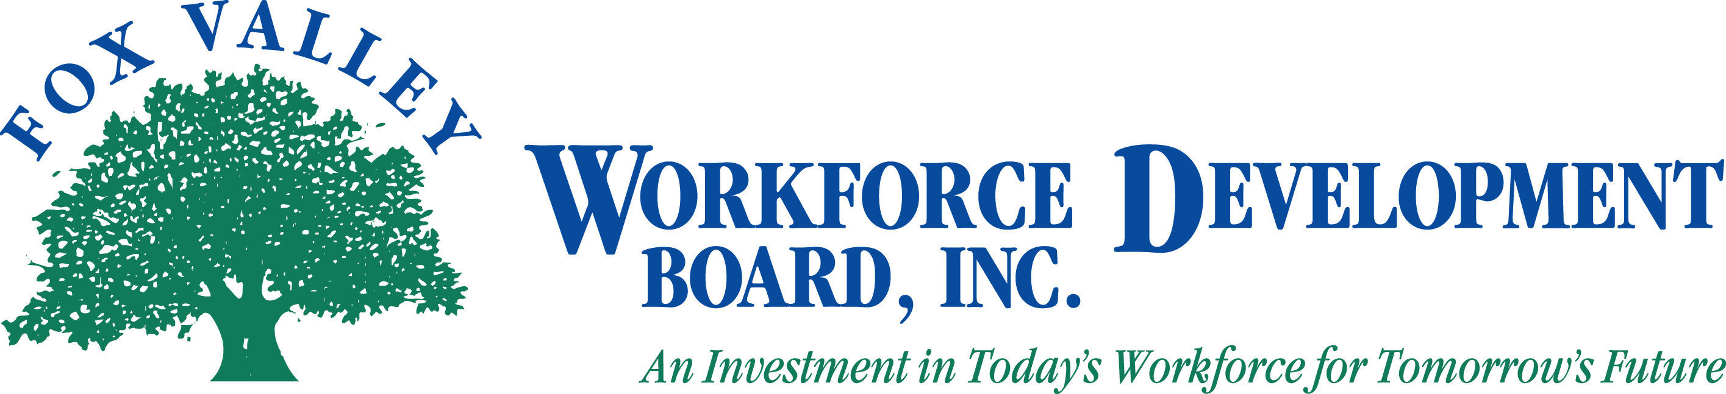

AGENDA
The Fox Valley Workforce Development Board will hold a joint
LEO and Board of Director meeting on
Thursday, May 15, 2014 at 2:00 P.M.
at Oshkosh Job Center

- Call to Order
- Introductions
- Approval of Minutes from 03/20/2014 Board meeting (Action Item)
- Approval of Minutes from 03/03/2014 LEO meeting (Action Item)
- PY13 Review / PY14 Preview
- Committee Updates
  - HR/Personnel
  - One Stop
    - Extension of Contracts (Action Item)
  - Youth Committee
    - Youth RFPs (Action Item)
  - Finance Committee
    - Budget Recommendations & 990 Review
- Approval of PY14 Budget (Action Item)
- Report of Ad-hoc Nominating Committee
- Election of Officers (Action Item)
- Review Consortium Agreement (discussion only)
- Review Joint Agreement (discussion only)
- Recognition of Board members
- Adjournment
Next BOD meeting is: August 21, 2014
Next LEO meeting is: TBD

Meeting location:
Oshkosh Job Center
219 Washington Street #107
Oshkosh, WI 54901
920-232-6273
For additional information, if you require assistance to attend the meeting or to access meeting materials, or if you need an interpreter, contact Beth Reinke at FVWDB, 1401 McMahon Road, Suite 200, Neenah, WI 54956, breinke@fvwdb.com, 920-720-5600.

