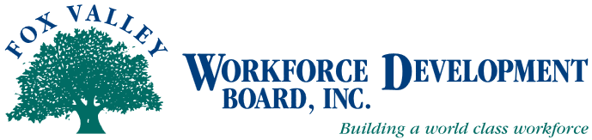

Fox Valley Workforce Development Board
Finance Committee Agenda

The Finance Committee of the Fox Valley Workforce Development Board will hold a meeting on Monday, February 9, 2015 @ 2:30 PM at the Oshkosh Job Center.

- Call to Order
- Approval of 11/10/14 minutes (Action Item)

Old Business
- DOL Audit Update
- Feedback on revised Financial Statement Format
- PY’13 Form 990 & 990T Tax Return
- Financial Policy Updates

New Business
- Procurement Policy update (Action Item)
- PY14 Audit RFP – recommend audit firm (Action Item)
- Revised budget update (Action Item)
- PY15 Treasurer
- DWD annual fiscal review/monitoring – week of March 16th

Quarterly Review and Approvals (Action Items)
- Credit Card Statements
- Check Registry – Checks Over $5,000
- Review Board Financial Reports To-Date

- Future Meeting Reminders:
- Monday, May 11, 2015, 2:30 PM, Oshkosh Job Center
- Monday, August 10, 2015, 2:30 PM, Oshkosh Job Center

- Adjournment

Meeting Location:
Oshkosh Job Center
219 East Washington Street
Oshkosh, WI 54901
920-232-6273

For additional information, if you require assistance to attend the meeting, in accessing meeting materials, or if you need an interpreter, contact Beth Reinke at FVWDB, 1401 McMahon Road, Suite 200, Neenah, WI 54956, breinke@fvwdb.com, 920-720-5600

