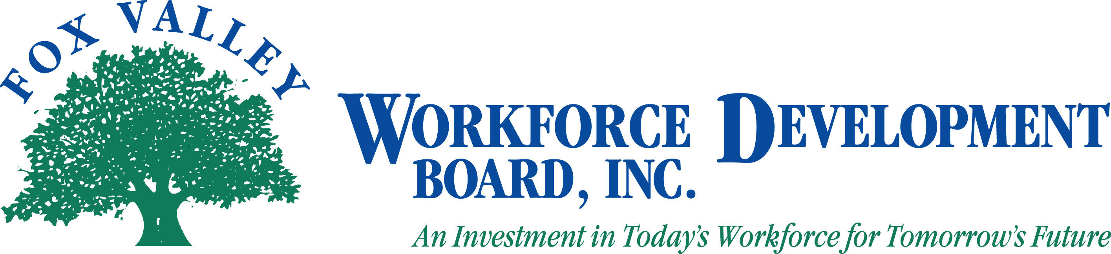

Fox Valley Workforce Development Board, Inc.
Executive Committee Meeting
November 16, 2011 at 8:30 a.m.

The Fox Valley Workforce Development Board Executive Committee will hold a meeting on Wednesday, November 16, 2011 at 8:30 a.m.

- Call to Order
- Approval of Minutes from September 6 and October 11, 2011 (Action Item)
- Approval of Policy Revisions, new Policies and Procedures (Action Item)
- PY10 Audit Update
- Move to Closed Session as per State Statute 19.85(1)(c) for Personnel (Action Item)
- Return to Open Session as per State Statute 19.85(1)(c) for Personnel (Action Item)
- Approval of Actions Discussed in Closed Session
- 2012 Health Insurance Renewal
- PY11 WIA Plan
- LEO Consortium Agreement and LEO-WDB Joint Agreement
- PY11 First Quarter Budget Expenditures
- DWD and DOL Updates
- One-Stop Center Locations
- Administrative Office Options
- FVWDB Agenda
- Announcements
- Adjournment

Please note: If you wish to attend the meeting, please visit the Administrative Office at 1401 McMahon Drive, Neenah. During the closed session portion of the meeting, the public will be asked to leave the room.

